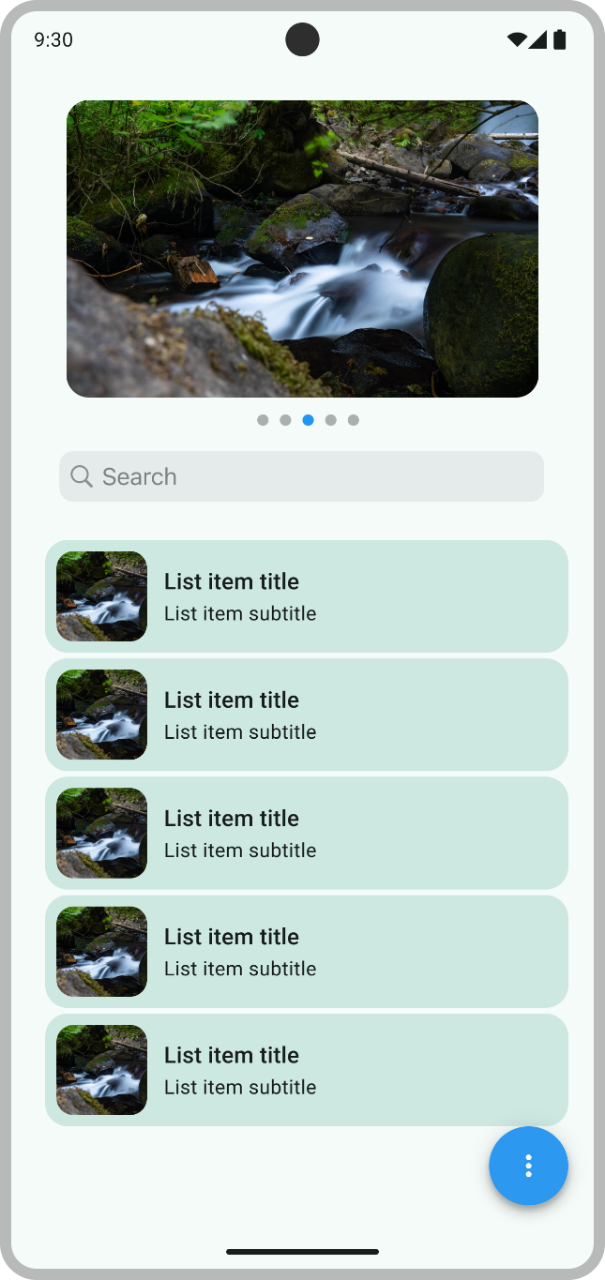

* Images carousel: when user swipe left or right, list content should change accordingly. The images carousel can handle any number of images.
* The list: when user scrolls up the whole page should scroll with it. The list can handle any number of items.

P.S. images and list content can be local or loaded from the internet.

* Search: Search bar should pin top when it reaches screen top. When user enter text, it should filter the labels in the list based on the user input.
* Floating action button should show a nice bottom sheet dialog that contain a small statistic that consist of the count of items for each page and show the top 3 occurrence character in the list. i.e  
  listOf(“apple”, “banana” , “orange”, “blueberry”)  
  List 1 (25 items)  
  a = 5  
  e = 4  
  r = 3
* Don’t use third party libraries. (You can use Android support libraries)
* The code will be reviewed.
* You’ve got 3.5 hours.
* Code in Kotlin please
* Implement the requirements using both Jetpack Compose & XML, each implementation should be pushed to a separate git branch.
* Once done, push your code to GitHub and share the link with us.

Please do contact us if you have any question

Good luck 😊